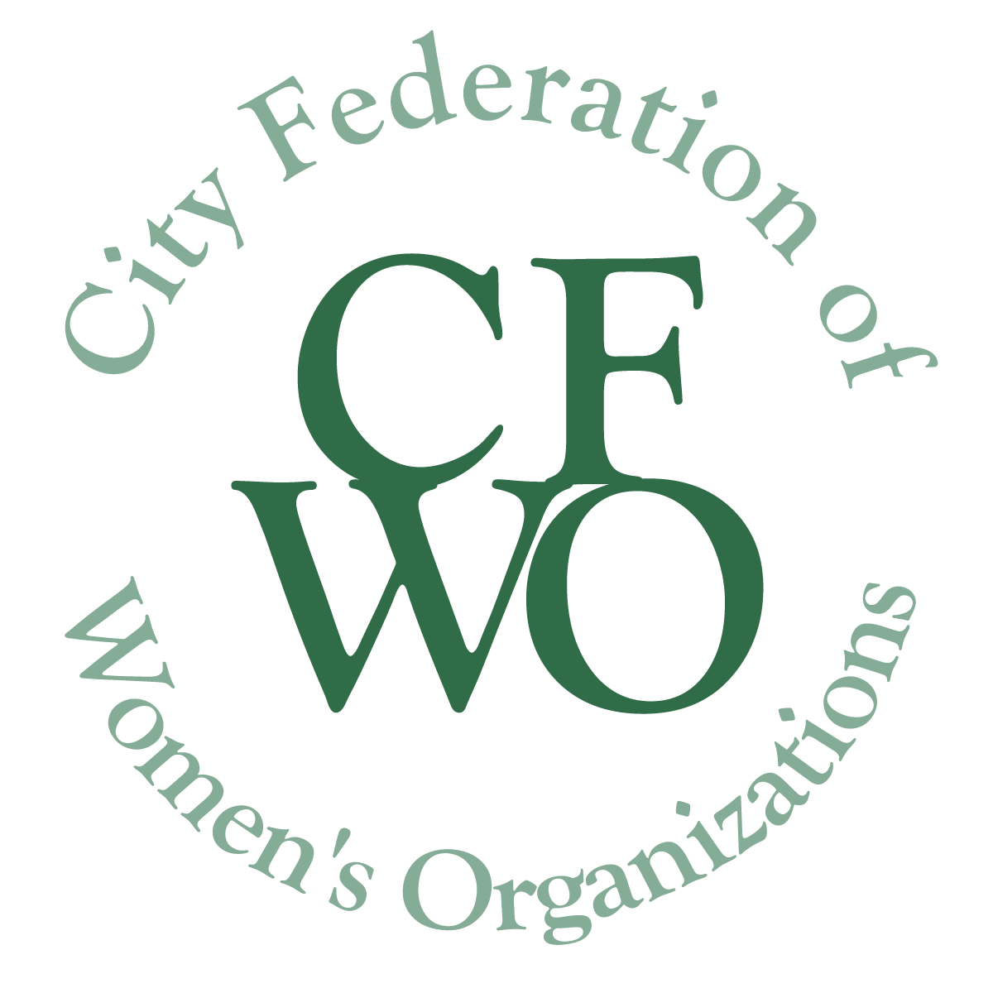CITY FEDERATION OF WOMEN’S ORGANIZATIONS
WOMEN BUILDING COMMUNITY GRANTS
2017-18 GRANT PROGRAM INTERIM REPORT FORM
Due: with application for 2018-19 grant cycle

If you will be applying for a 2018-19 grant, due September 21, you must submit a final report, or an interim report if the project is not yet complete, together with this application. An interim report should include progress to date. However, you do not have to answer all the questions. Your final report will still be due January 31, 2019.

Please include the name of the program in the file name of the document.
Please delete all instructions in italic before returning this form.

- Organization name or sponsoring organization:

- Name of project that was funded by CFWO:

- Person responsible for project:

- Amount of grant from CFWO:

- Current project budget:

- Briefly describe the purpose of the project that was funded:

- What is the status of the project to date:

- What were the challenges in implementing this grant? (Please be specific,)

- Describe the benefits that this grant made possible so far and to whom.

- How many women/girls has this grant served so far?

- Will the project continue or be changed? Describe why or why not.

The City Federation of Women’s Organizations is interested in receiving photographs and/or narrative about your grant-funded project. We would like to learn from the women/girls who were involved, and about how the grant benefited the target audience and the community. It is not necessary to identify the names of those photographed or quoted. It is important to obtain media release forms for all images sent to us.

Please send by email to: grants@womenbuildingcommunity.org

