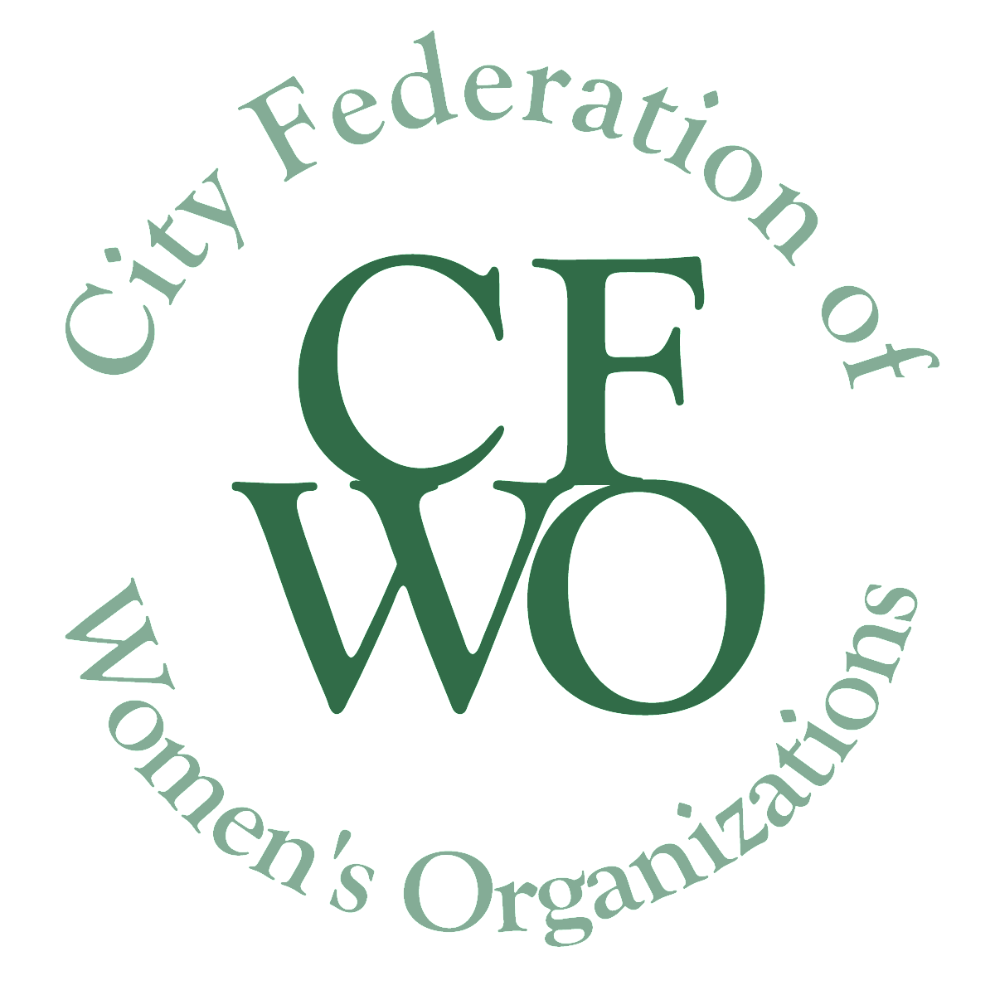
City Federation of Women’s Organizations
WOMEN BUILDING COMMUNITY GRANTS
WBC Innovation Grant for $10,000

Application Form for 2019 Innovation Grant
Application Deadline March 15, 2019, at 6 pm

All italicized text in this application can be erased from your submitted request (including this sentence!) Please maintain the format and page breaks as they appear in the application.

Please complete this Application in the format requested, following the same page layout, and submit electronically, attached as a pdf to a covering email to grants@womenbuildingcommunity.org. Alternatively, you may print the documents in the format requested and send them via postal mail to CFWO, 101 E. State Street, #200, Ithaca, NY 14850. You must include all required attachments. In your email/letter make sure the name of your organization and name of project to be funded are on the subject line.

Please save your document in pdf format using the project name in the file name. Please ensure the project name is at the top of each page of your document.

Please bundle ALL documents requested into ONE Pdf Binder. If you feel you have to send more than one document because of size, please give same file name plus # of document.

Please delete instructions and all unnecessary text from your document.

Please ensure all attachments also have the same file name.

Page 1. COVER PAGE:
- Innovation Grant Project Name ___________________________________________
- Organization Name ____________________________________________________
- Organization’s Mission __________________________________________________
- Organization’s Address__________________________________________________
- Organization’s phone number and email address _____________________________
____________________________________________________________________
- Name of Executive Director/President ______________________________________
- Federal Tax ID number of applicant or of sponsoring organization ________________
- Name of Executive Director/President of sponsoring organization if applicable
_____________________________________________________________________
- Contact information for Executive Director/President of sponsoring organization
_____________________________________________________________________
- Contact name, email address and phone number of person responsible for this project and who will submit final report ___________________________________

_____________________________________________________________________

- Total Project Budget ____________________________________________________
- Estimated number of women and/or girls impacted by this grant __________________
- Signature of Executive Director/President of applying organization

_____________________________________________________________________
Page 2 NARRATIVE:
Your narrative should answer the following points. Please do not exceed 2 pages.

- Provide a brief paragraph describing the project for which this Innovation Grant is being sought, include project goals, history if appropriate, primary activities and target population.

- Provide a statement of need for this project. Describe how the project will address this need and how it will significantly improve the lives of women and girls.

- Include names of organizations or individuals with whom you will collaborate on the implementation of this project if applicable and how they will be involved.

- Include a timeline for the use of these funds.

- Provide an explanation of the process that will be used to evaluate the project and to determine if the project has met its goals.

REQUIRED ATTACHMENTS:

- Project Budget
A complete, itemized project budget for this grant that lists all project activities, the costs related to each activity, and the source of the funding used to support these costs, including this grant request. In-kind donations, matching funds, and additional funds from other sources should also be included in the budget.

- List of the Organization’s current Board Members

- Signed letter of agreement from fiscal sponsor if applicable

- Organizations that received any WBC grant in December 2017, for use during 2018, must attach a final report of the project to the 2019 grant application, if a final report has not been submitted already. The report form can be found at http://www.womenbuildingcommunity.org/index.php?page=grants-information.

In addition, letters of support from partnering organizations and other sponsors are always helpful. Please add these at the end.

