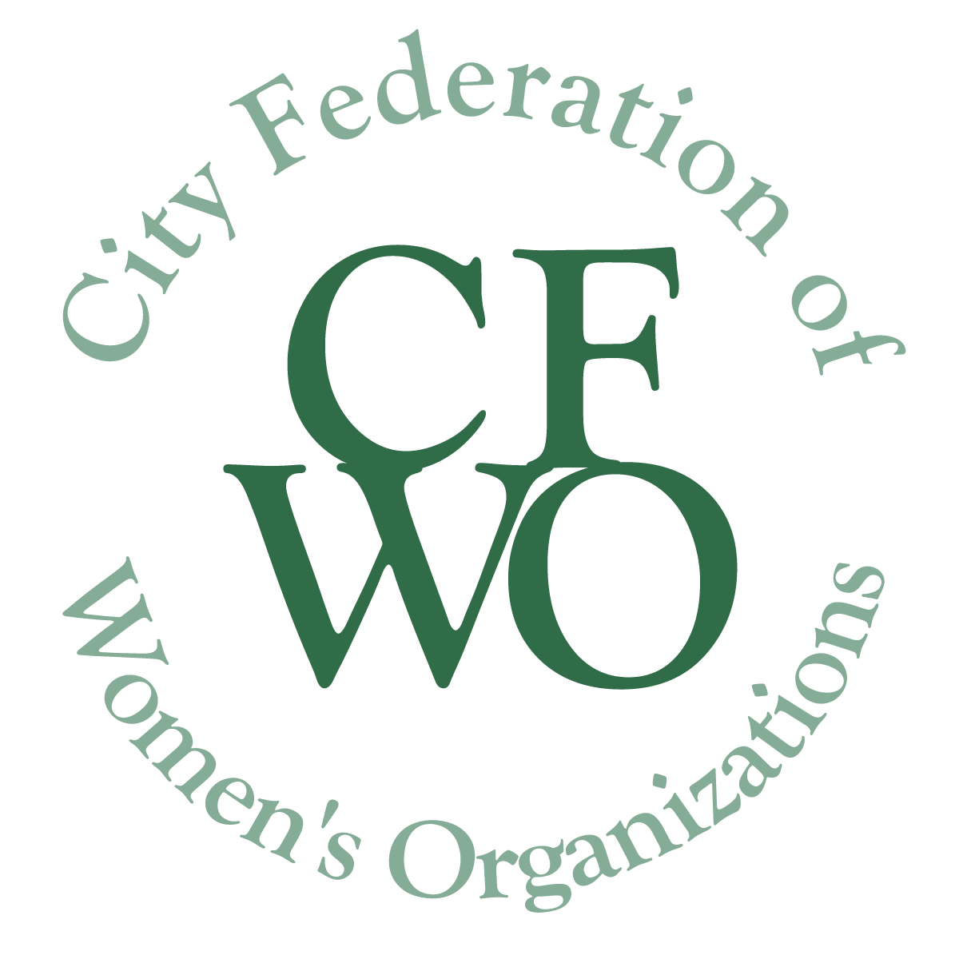 CITY FEDERATION OF WOMEN’S ORGANIZATIONS
WOMEN BUILDING COMMUNITY GRANTS

Grant Program FINAL Report Form

Due: As stated in Guidelines

Please include the name of the program in the file name of the document.
Please delete all text in italics before submitting this document.

- Organization name or sponsoring organization:

- Name of project that was funded by CFWO:

- Person responsible for project:

- Amount of grant from CFWO:

- Final project budget:

- Briefly describe the purpose of the project that was funded:

- Were the anticipated outcomes achieved? Why or why not? How was the project evaluated?

- What were the challenges in implementing this grant? (Please be specific.)

- Describe the benefits that this grant made possible and to whom.

- How many women/girls did this grant serve?

- Will the project continue or be changed? Describe why or why not.

The City Federation of Women’s Organizations is interested in receiving photographs and/or narrative about your grant-funded project. We would like to learn from the women/girls who were involved, and about how the grant benefited the target audience and the community. It is not necessary to identify the names of those photographed or quoted. It is important to obtain media release forms for all images sent to us.

Please send by email to: grants@womenbuildingcommunity.org

