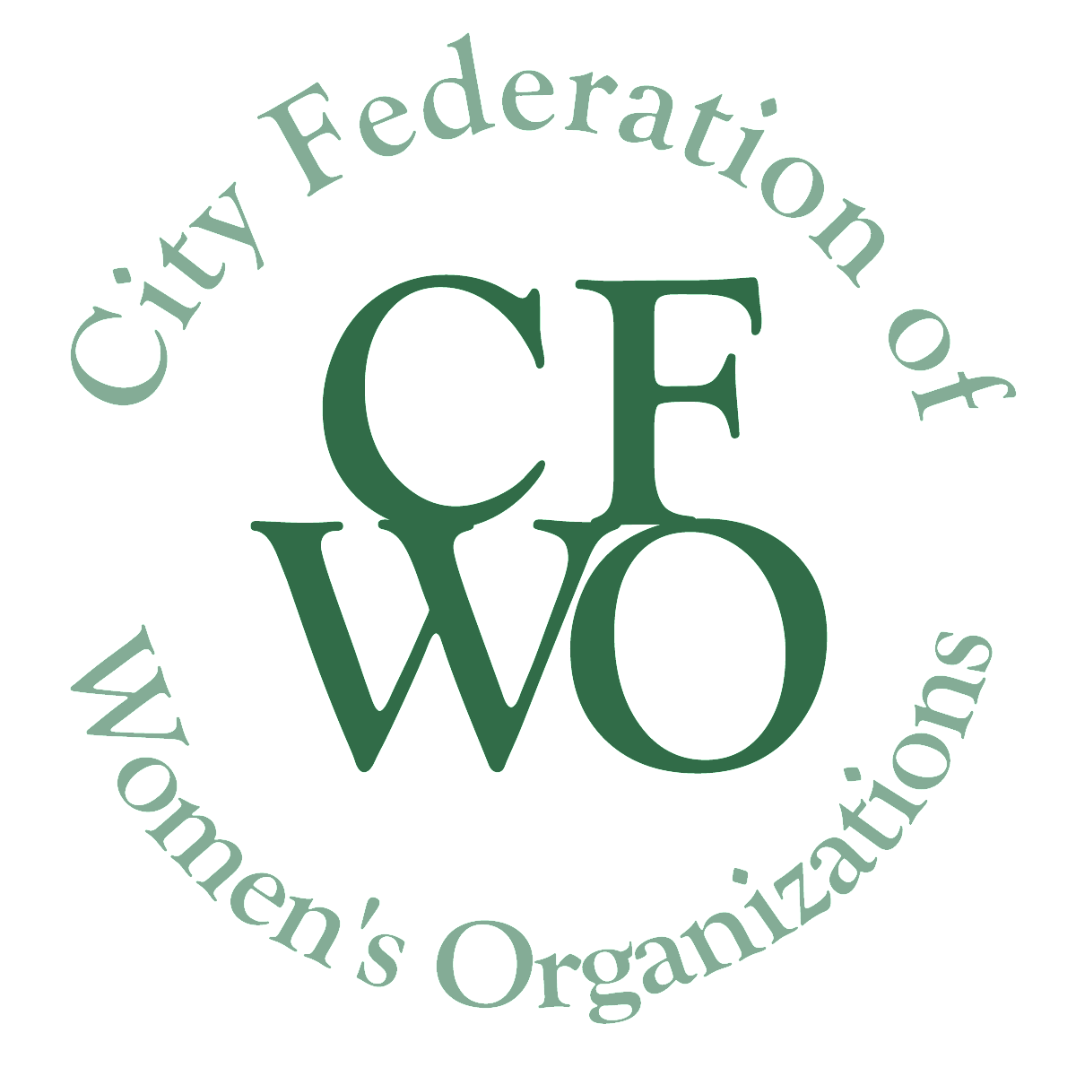
City Federation of Women’s Organizations
WOMEN BUILDING COMMUNITY GRANTS
WBC Innovation Grant for $10,000

Application Form for 2020 Innovation Grant

All italicized text in this application should be erased from your submitted request (including this sentence!)

The purpose of the Women Building Community (WBC) Grants of the City Federation of Women’s Organizations (CFWO) is to act as a catalyst for the improvement of the lives of all women and girls in Tompkins County, thus making a contribution to the community as a whole. WBC Grants support all women and girls regardless of race, color, national origin, religion, sex, gender identity (including gender expression), sexual orientation, disability, age, marital status and socio-economic status. Project areas considered for funding, and other useful information, are in the Grants Guidelines.

To prepare your grant application:

___ Maintain the format and page breaks as they appear in this application.

___ Use no smaller than 12 Pt font.

___ Delete instructions and all unnecessary text.

___ Put the project name at the top of each page.

___ Save your document in pdf format using the title of the project in the file name.

___ Ensure all attachments also have the same file name.

___ Bundle ALL documents requested into ONE Pdf Binder. If you feel you have to send more than one document because of size, please give the same file name plus a number of the document.

To submit your grant application:

Submit electronically, attached as a pdf to a covering email to grants@womenbuildingcommunity.org.

Alternatively, you may print the documents in the format requested and send them via postal mail to CFWO, 101 E. State Street, #200, Ithaca, NY 14850.

You must include all required attachments. In your email/letter make sure the name of your organization and name of project to be funded are on the subject line.

Page 1. COVER PAGE:
- Innovation Grant Project Name ___________________________________________
- Organization Name ____________________________________________________
- Organization’s Mission __________________________________________________
- Organization’s Address__________________________________________________
- Organization’s phone number and email address _____________________________
____________________________________________________________________
- Name of Executive Director/President ______________________________________
- Federal Tax ID number of applicant or of sponsoring organization ________________
- Name of Executive Director/President of sponsoring organization if applicable
_____________________________________________________________________
- Contact information for Executive Director/President of sponsoring organization
_____________________________________________________________________
- Contact name, email address and phone number of person responsible for this project and who will submit final report ___________________________________

_____________________________________________________________________

- Total Project Budget ____________________________________________________
- Estimated number of women and/or girls impacted by this grant __________________
- Signature of Executive Director/President of applying organization

____________________________________________________________________

- Date of Signature

____________________________________________________________________
Page 2 NARRATIVE:
Your narrative should answer the following points. Please do not exceed two pages.

- Provide a brief paragraph describing the project for which this Innovation Grant is being sought. Include project goals, history if appropriate, primary activities and target population.

- Provide a statement of need for this project. Describe how the project will address this need and how it will significantly improve the lives of women and girls.

- Include names of organizations or individuals with whom you will collaborate on the implementation of this project if applicable and how they will be involved.

- Include a timeline for the use of these funds.

- Provide an explanation of the process that will be used to evaluate the project and to determine if the project has met its goals.

REQUIRED ATTACHMENTS:

- Project Budget
A complete, itemized project budget for this grant that lists all project activities, the costs related to each activity, and the source of the funding used to support these costs, including this grant request. In-kind donations, matching funds, and additional funds from other sources should also be included in the budget.

Do not attach the budget for your whole organization.

- List of the Organization’s current Board Members

- Signed letter of agreement from fiscal sponsor if applicable

- Organizations that received an Innovation grant in 2019, must attach an interim report of the project to the 2020 grant application, if a final report has not been submitted already. The report form can be found at http://www.womenbuildingcommunity.org/index.php?page=grants-information.

In addition, letters of support from partnering organizations and other sponsors are always helpful. Please add these at the end.

