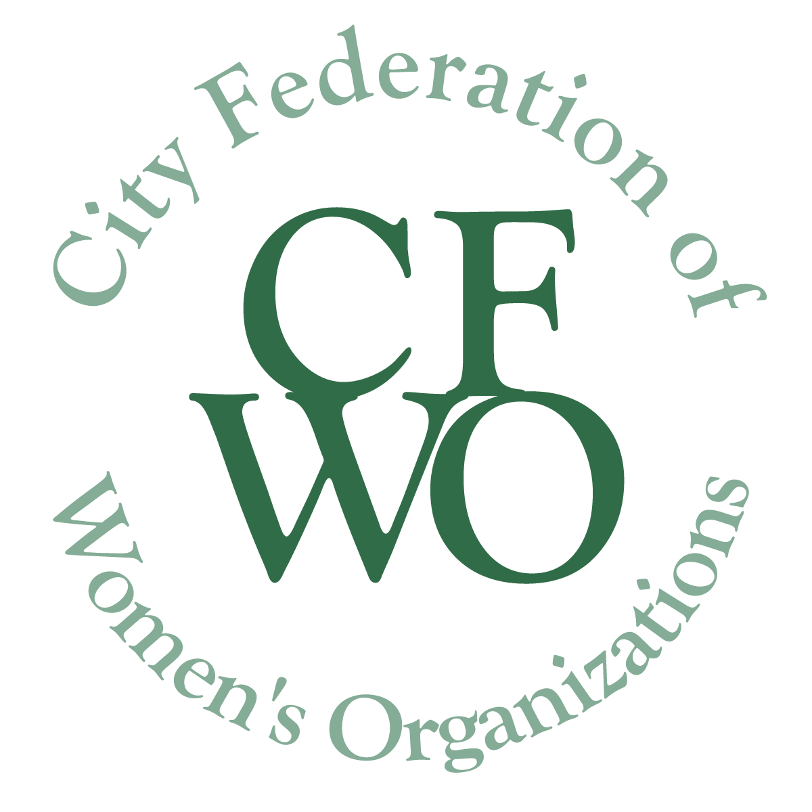
Women Building Community Grants

Guidelines

The mission of the City Federation of Women’s Organizations (CFWO) is to act as a catalyst for the improvement of the lives of women and girls in Tompkins County, thus making a contribution to the community as a whole.

Women Building Community (WBC) Grants support women and/or girls of all races, colors, national origins, religions, gender identities (including gender expression), sexual orientations, abilities, ages, marital status and socio-economic status.

HISTORY

The City Federation of Women’s Organizations was founded in 1910 by the Ithaca Woman’s Club, the Political Study Group (now the League of Women Voters) and the Women’s Christian Temperance Union (now dissolved), believing that they could accomplish more by working together. The CFWO was incorporated in 1912. Then in 1920 the Federation purchased the property on the corner of Seneca and Cayuga Streets in downtown Ithaca. The original house, and more modern building that later replaced it, were known as the Women’s Community Building (WCB). Through the years member organizations (for many years totaling over sixty) enabled the CFWO to provide housing for women, community meeting space, and to serve as an incubator for numerous efforts enriching the lives of women and children in our community.

The proceeds from the sale of the WCB in 2012 now fund an endowment to continue the CFWO mission through grants and scholarships. The CFWO is managed by a volunteer Board of Directors which includes delegates from the CFWO Legacy Organizations and individuals representing the community.

GRANTS
Women Building Community Grants are made to projects that improve the quality of life for women and girls in Tompkins County. While the overall mission of the CFWO is to improve the lives of both women and girls, individual projects may focus on serving one group and/or the other.

WBC Unexpected Needs Grants (up to $1,000)
A grant opportunity to help fund unexpected needs or emergencies or to take advantage of an unexpected opportunity. Applications may be submitted at any time; awards will be made following the next available Board Meeting.
WBC Grants (up to $5,000, multiple grants)
Full or partial funding is available for new or ongoing projects. Applications are accepted in September; the deadline will be posted on our website. Applicants will be notified in late November of the Board’s decisions. Projects must be completed by December 31st of the year after the Fall award is made.

WBC Innovation Grant ($10,000, only one grant)
This is a single, highly competitive grant awarded to a project that will have a significant impact on the lives of those it serves in our community. Its target is a new project that is both innovative and resourceful. Consideration will be given to an existing project only if the additional funding will produce a major impact on that existing project.

All Grants If funds are not expended for the stated purpose(s) and within the time period specified, they must be returned to the CFWO.

ELIGIBILITY

The City Federation of Women’s Organizations (CFWO) welcomes grant applications from nonprofit organizations that are tax-exempt under section 501(c)(3) of the Internal Revenue Code and from governmental agencies serving Tompkins County.

Organizations without a 501(c)(3) designation are required to be sponsored by a nonprofit organization that does have a 501(c)(3) designation. Applications submitted by an entity under the auspices of another agency must include a written statement signed by the agency’s board president/executive director on behalf of the organization, agreeing to act as the entity’s fiscal sponsor, to receive grant monies if awarded, and to oversee the proposed project including the Final report.

PROJECT AREAS CONSIDERED FOR FUNDING

In addition to addressing needs and opportunities that improve the quality of life for Tompkins County women and/or girls, projects to be funded must meet at least one of the following criteria:

- Community Development and Engagement: Activities that increase participation of women and/or girls in developing programs that enhance community life and/or cooperation among neighbors

- Education, Youth Development, Career Development: Activities that promote or strengthen the education of women and/or girls, both in and out of the classroom

- Gender Equity: Activities that address gender-equity issues

- Health: Activities that improve the health access and outcomes of women and/or girls

- Human Services: Activities that support public safety, employment, food and nutrition, housing and shelter, disaster preparedness, and other relief for women and/or girls

- Social Justice: Activities that seek to remove systemic barriers and obstacles to social equity for women and/or girls

- Administrative/operating costs directly related to a qualifying project

PROJECT AREAS NOT CONSIDERED FOR FUNDING

- Requests for funding to reduce or retire debt of the organization

- Projects operated by religious organizations for religious purposes

- Political parties or campaigns

- Administrative/operating costs not directly related to the proposed project

- Annual appeals and membership contributions

- Endowment campaigns
GRANT APPLICATION FORMS

These forms may be downloaded from https://womenbuildingcommunity.org/available/.

Organizations may submit more than one application during each grant cycle. Organizations are encouraged to seek additional funds from other sources as well.

Applications must be completed and sent to: grants@womenbuildingcommunity.org.

All applications must be received by the deadlines posted on our website.
Late applications will not be accepted.

REPORTING PROCEDURES

All organizations receiving Women Building Community Grants must submit a Final report. Forms may be downloaded from https://womenbuildingcommunity.org/available/.

FINAL REPORTS DUE | Innovation grant | Up to $5,000 grant | Unexpected Needs grant
If awarded in 2021 | 6/30/2022 | 1/31/2023 | Upon project completion a brief statement attesting to the use of the funds must be sent to CFWO at grants@womenbuildingcommunity.org
If awarded in 2022 | 6/30/2023 | 1/31/2024
If awarded in 2023 | 6/30/2024 | 1/31/2025

Note: Organizations that apply for a new grant before submitting a Final report for a previously funded project must submit either the Interim or Final report with the new grant application.
(This does not apply to Unexpected Needs grants.)

PUBLIC RELATIONS

Grant recipients must mention the City Federation of Women’s Organizations as a funding source in all publicity and promotional material about the funded project. They are requested to submit personal testimonial reports of the project to CFWO for use on our website and in social media.
Please Do NOT identify the names of participants who are quoted. Each organization is responsible for obtaining all media release forms for testimonies sent to us.

If you have any questions about these grants, please contact the CFWO
at grants@womenbuildingcommunity.org

