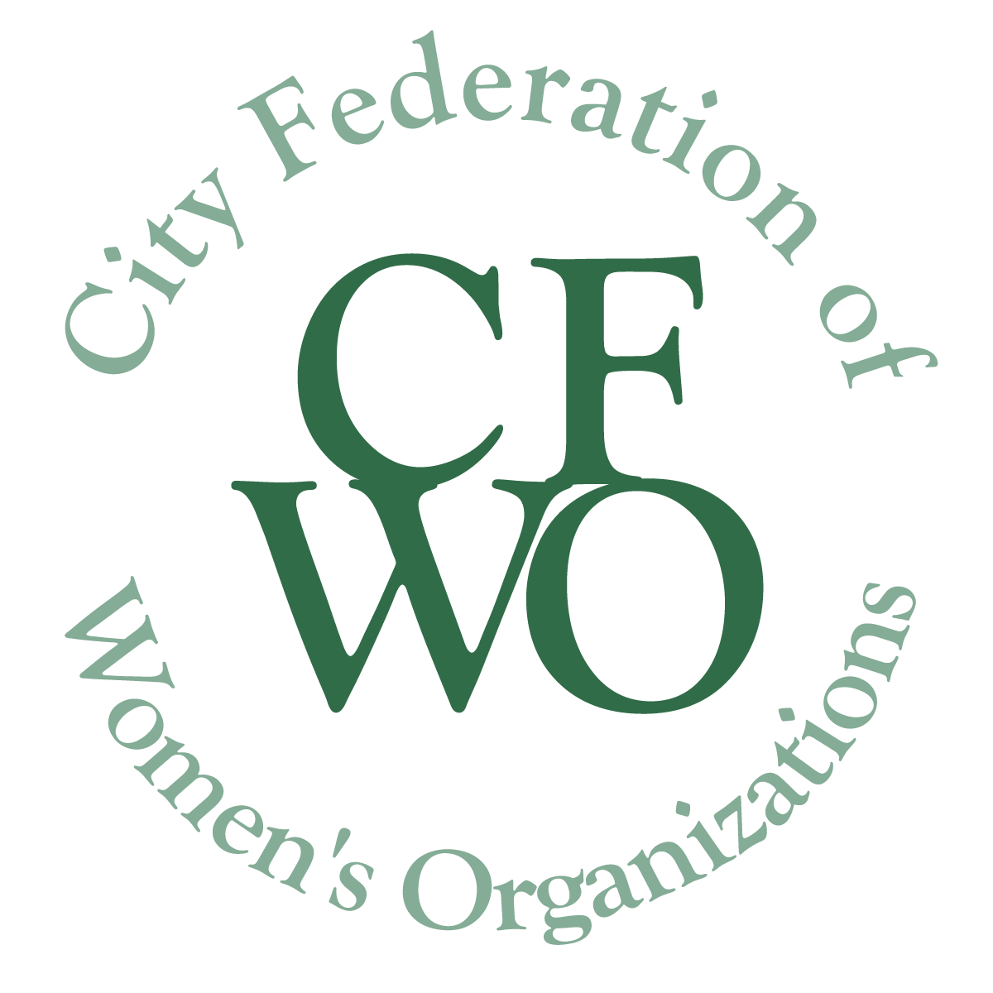
Women Building Community Grants
(Up to $5,000)

Instructions and Application Form

Application Deadline Friday, September 23, 2022 at 5 pm

This page of instructions and any other text in italics should be deleted from your submitted request.
The mission of the City Federation of Women’s Organizations (CFWO) is to act as a catalyst for the improvement of the lives of women and girls in Tompkins County, thus making a contribution to the community as a whole.

Women Building Community (WBC) Grants support women and/or girls of all races, colors, national origins, religions, gender identities (including gender expression), sexual orientations, abilities, ages, marital status and socio-economic status.

The CFWO Grant Guidelines and Tips (https://womenbuildingcommunity.org/wp-content/uploads/2023/03/Application-Tips-2020.pdf) describe areas considered for funding, and other useful information. We STRONGLY recommend you review these when writing your application.

To prepare your grant application

___ Maintain the format and page breaks as they appear in this application.

___ Use at least 12 Pt font.

___ Put the project name at the top of each page.

___ Complete all required attachments (detailed on the last page).

___ Save your document in pdf format using the title of the project in the file name.

___ Ensure all attachments also have the same file name.

___ Bundle ALL required documents into ONE Pdf Binder.
If you need to send more than one document because of size, give the same file name plus a number of the document. (Each organization is responsible for obtaining all media release forms for images sent to us.)

To submit your grant application
,
To submit, send an email to grants@womenbuildingcommunity.org with the pdf of your application attached. You must include all required attachments.

In your email, please put the name of your organization and the name of the project to be funded in the subject line.
APPLICATION
Page 1. COVER PAGE
- WBC Grant Project Name:
- Organization Name:
- Brief Organization Mission:
- Organization Address:
- Organization phone number:
- Your organization:
  - Name of Executive Director/President
  - Email address for Executive Director/President
  - Federal Tax ID number, unless with fiscal sponsor
- If applicable, your fiscal sponsor:
  - Name of Executive Director/President
  - Email address for Executive Director/President
  - Federal Tax ID number
- The person responsible for this project and who will submit the final report:
  - Name
  - Email address
  - Phone number
- Total Project Cost:
- Amount requested from the CFWO (Up to $5,000):

- If only partial funding is awarded how will your project be affected? How will you change the project or raise additional funds?

- Estimated number of women and/or girls impacted by the amount requested from the CFWO:

- Signature of Executive Director/President of applying organization:

- Date of Signature:

Page 2. NARRATIVE

Your narrative should answer the following points. Please do not exceed two pages.

- Provide a brief paragraph describing the project for which funds are being sought. Include project goals, history if appropriate, specific activities and target population. (Please do not include names of clients.)

- Provide a statement of need for this project. Describe how the project will address this need, why it is needed now, and how it will improve the lives of women and/or girls.

- If appropriate, include names of organizations or individuals with whom you will collaborate on the implementation of this project. Specify what activities will be provided by each partner.

- Provide a timeline for the use of CFWO funds. Awards are made in December 2023; funds may be used until December 31, 2024.

- Describe the evaluation process to determine how each of the project goals are met.

REQUIRED ATTACHMENTS

1. Project Budget

Attach a complete, itemized project budget that lists the costs and sources of funding related to the whole project. The budget must be for the time period during which these funds will be spent. (Funds will be available in early December 2023. Projects must be completed by December 31, 2024.)

Be sure it is clear which expenses will be covered by the CFWO requested funds. If this is a collaborative project, specify which expenses will be covered by each partner.

List the sources of funding used to support these costs. Include this grant request, in-kind donations, matching funds and additional funds from other sources, indicating which are pending.

Do not attach the budget for your whole organization.

2. List of the Organization’s current Board Members.

3. Signed letter of agreement from fiscal sponsor, if applicable.

Organizations without a 501(c)(3) designation are required to be sponsored by a nonprofit organization that does have a 501(c)(3) designation. Applications submitted by an entity under the auspices of another agency must include a written statement signed by the agency’s board president/executive director on behalf of the organization agreeing to act as the entity’s fiscal sponsor, to receive grant monies if awarded, and to oversee the proposed project including the Final report.

4. Interim/Final report

Organizations that apply for a new grant, before submitting a Final Report for a previously funded project, must submit either the Interim or Final Report with the new grant application. The report forms can be found at https://womenbuildingcommunity.org/available/.

OPTIONAL

Letters of support from partnering organizations and other sponsors are always helpful. Please add these at the end.

